SIMATS ENGINEERING
ASSESSMENT TOOL 3

NAME: M.Gowtham kumar REG.NO: 192525163
COURSE NAME: CSA1603 COURSE CODE: Data Warehousing and Data Mining

COURSE OUTCOME COVERED

CO4: Examine the applicability of clustering algorithms in real-world scenarios, presenting findings through clear reports with effective visualizations.
Assessment Tool Weightage: 20%

QUESTIONS: 05 Total Marks:50

Annexure A

COMPARITIVE ANALYSIS

Criteria | Scope of Items (2) | Comparison Depth(2.5) | Use of  Evidence  (2) | Critical  Thinking (2) | Clarity of  Presentation (1) | Total(10)
Weightage | 20% | 25% | 20% | 20% | 10% | 100%
Q1
Q2
Q3
Q4
Q5

Code of Conduct:

I _M.Gowtham kumar / 192525163_ (Name / Reg No) certify that this submission is my original work and that I have adhered to the guidelines specified for this assessment.
I understand that any violation of academic integrity rules will result in disciplinary action.

Signature of the student: M.Gowtham kumar

RUBRICS FOR CALCULATION:

 |  | Comparative analysis
Criteria | Weightag e (%) | Level 4 (Exemplary) | Level 3 (Proficient) | Level 2  (Developing  ) | Level 1  (Beginning  )
Scope of Items | 20% | Selects highly relevant items with clear scope and justification | Selects appropriate items with minor gaps | Selection is limited or partially relevant | Items are unclear or not relevant
Compariso n Depth | 25% | Provides detailed and comprehensive comparison across multiple aspects | Provides adequate comparison with some depth | Limited comparison with few aspects | Very minimal or no comparison
Use of  Evidence | 20% | Supports comparison with accurate data, examples, or references | Uses some supporting evidence with minor gaps | Limited or weak supporting evidence | No supporting evidence provided
Critical Thinking | 20% | Demonstrates strong critical thinking with clear interpretation and reasoning | Shows reasonable interpretation with minor gaps | Basic interpretatio n; lacks depth | No meaningful interpretatio n
Clarity of Presentatio n | 15% | Well-organized, clear, and logically structured presentation | Generally clear with minor issues | Somewhat  unclear or poorly structured | Disorganize d and  difficult to  understand

Annexure A
Q1 . Dataset: Assessment Tool 3: Comparative Analysis (25% → 5
Marks)
Time duration :45 Minutes Assessment Tool 3 (Low)
Q1 . Dataset: Customer Data
Customer Income (₹) Spending Score
C1 | 30000 | 60
C2 | 60000 | 40
C3 | 50000 | 70
C4 | 28000 | 65
C5 | 65000 | 35
Question:
Compare K-means and hierarchical clustering using this dataset and explain differences in performance and scalability. (BL3 – 1 Mark)
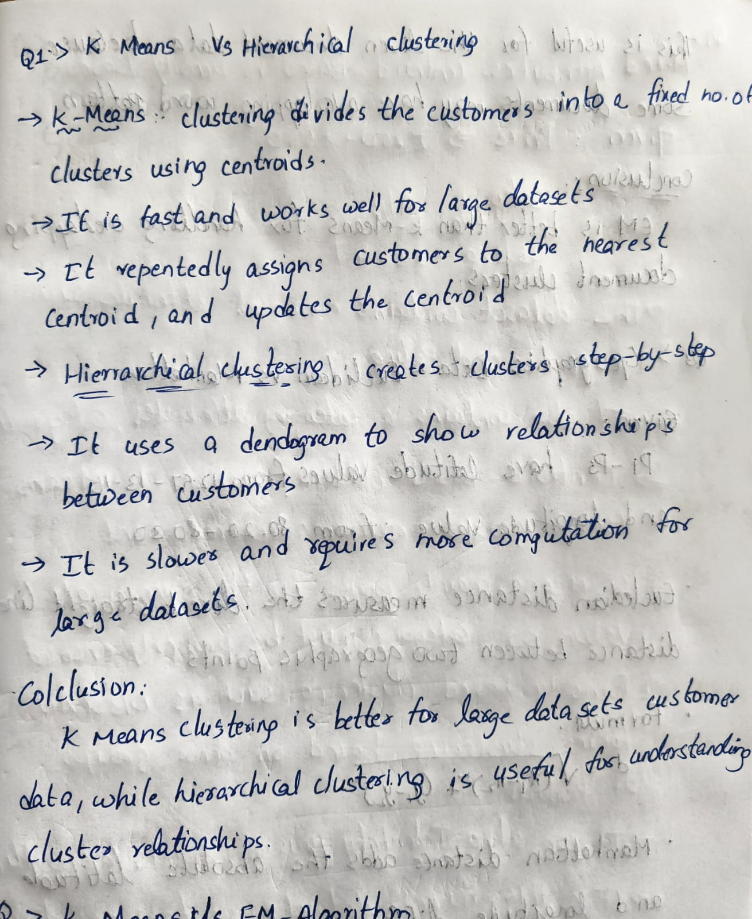
OUTPUT:
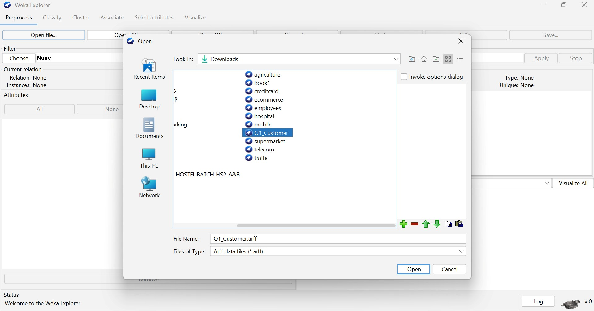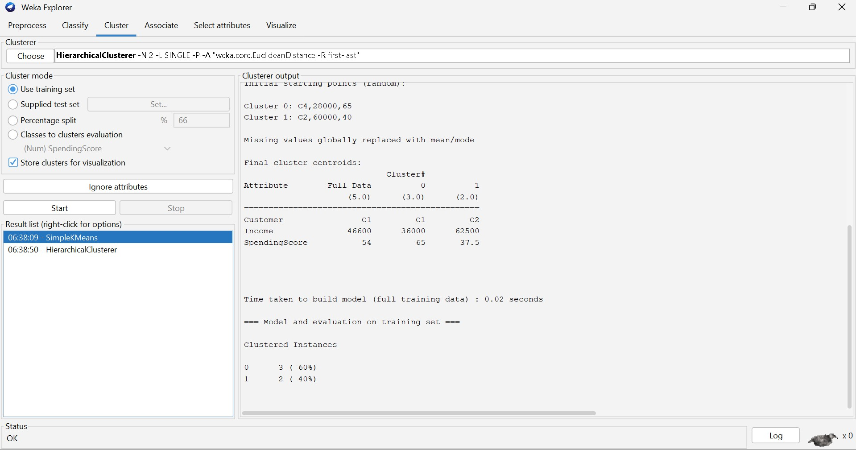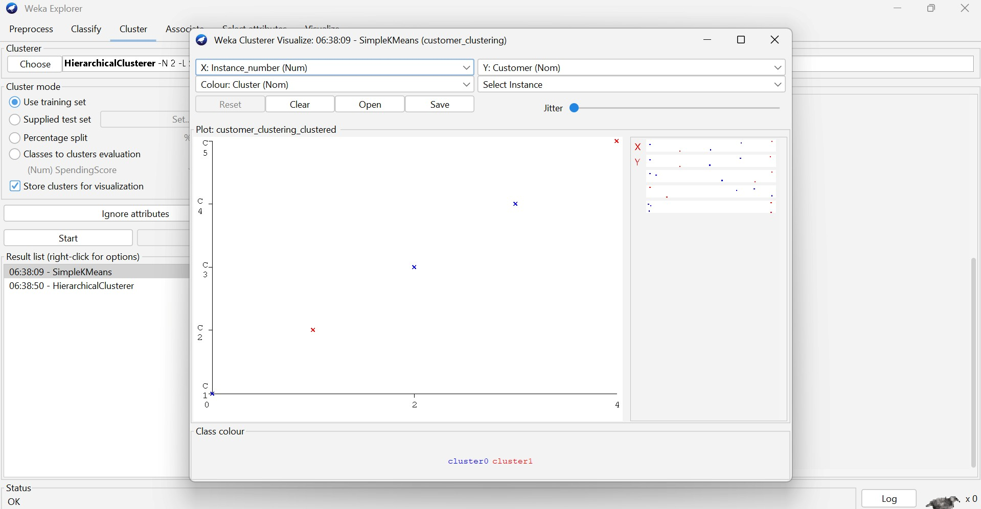
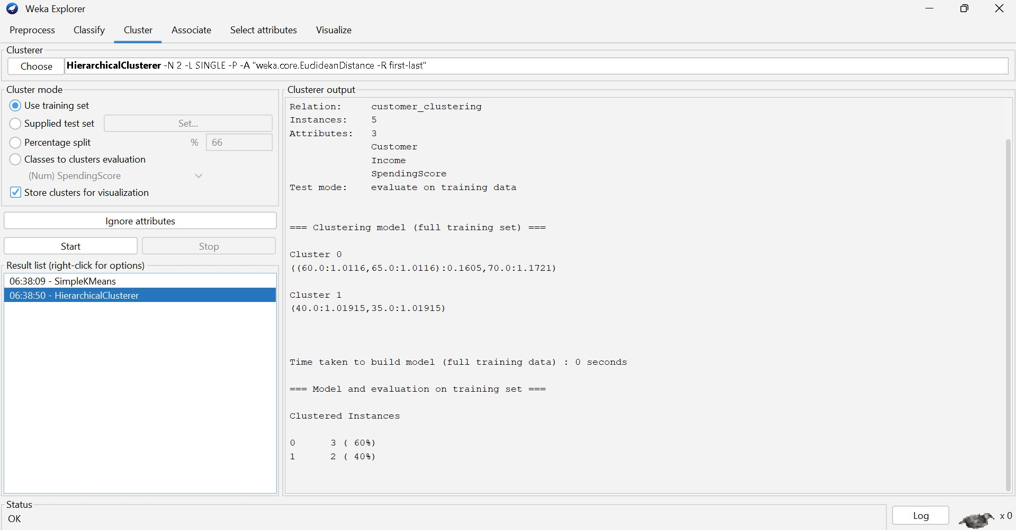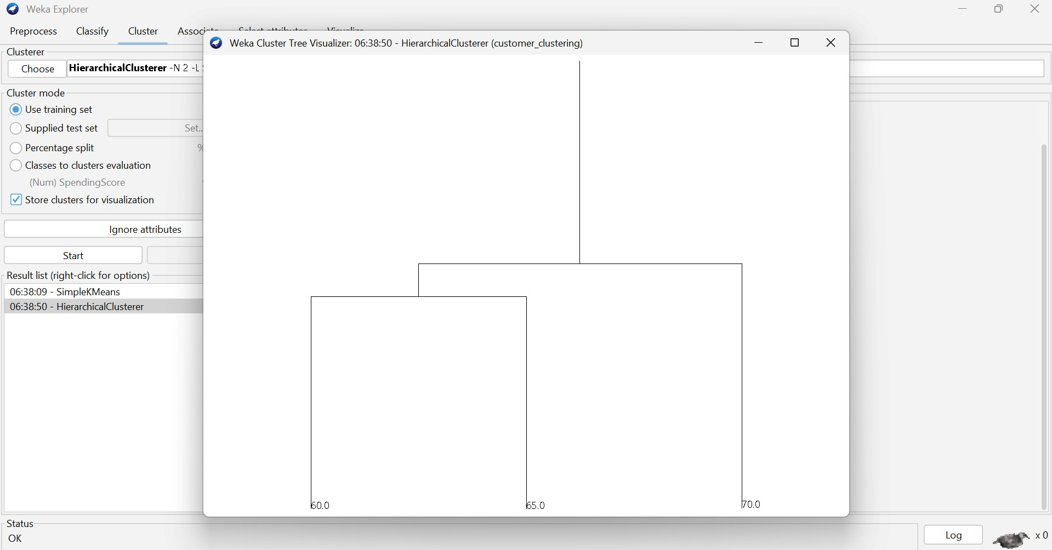
Q2. Dataset: Document Data Document Word1 Word2 Word3
D1 | 0.2 | 0.5 | 0.3
D2 | 0.1 | 0.6 | 0.3
D3 | 0.8 | 0.1 | 0.1
D4 | 0.75 | 0.15 | 0.1
D5 | 0.2 | 0.4 | 0.4
Question:
Compare K-means and EM algorithms in handling overlapping clusters for the given dataset.
(BL4 – 1 Mark)
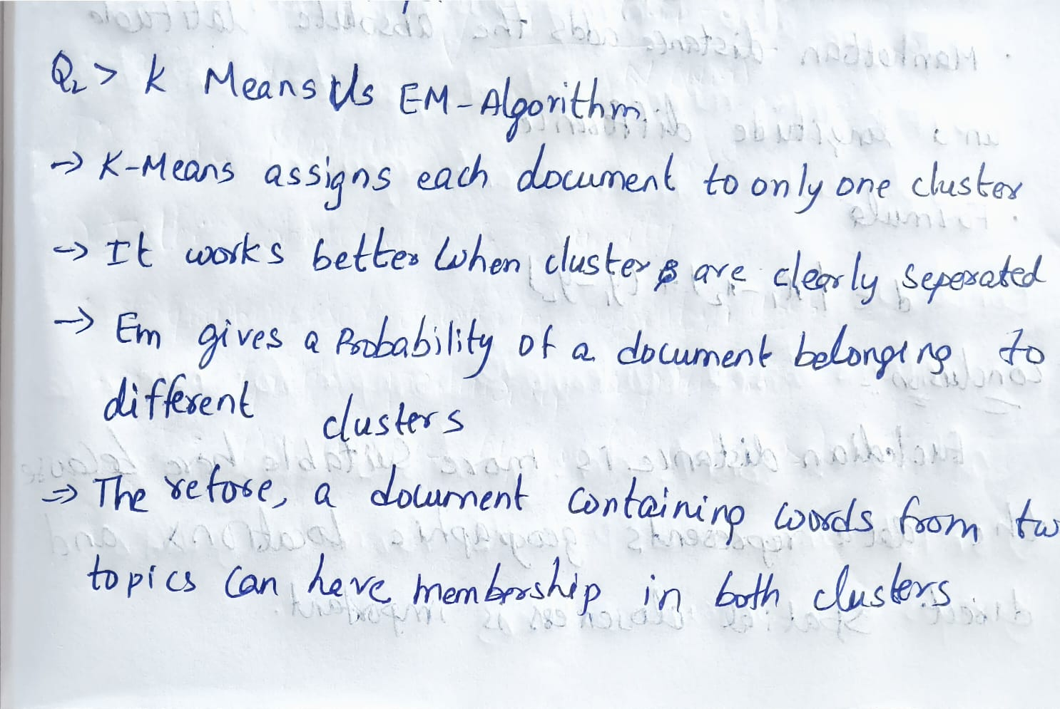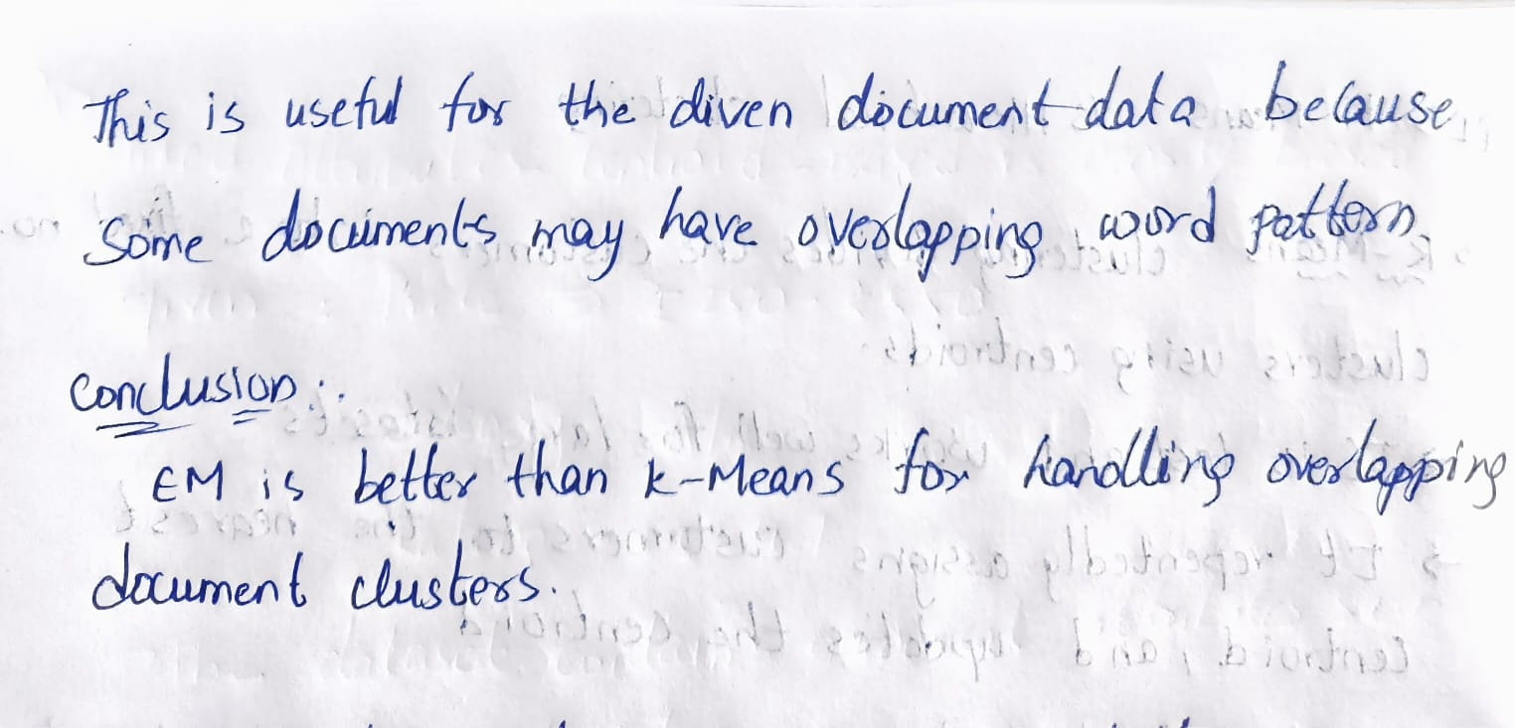
OUTPUT:
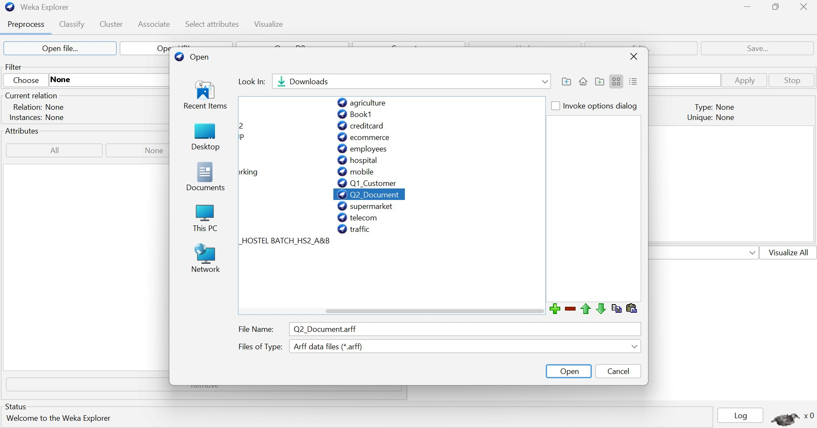

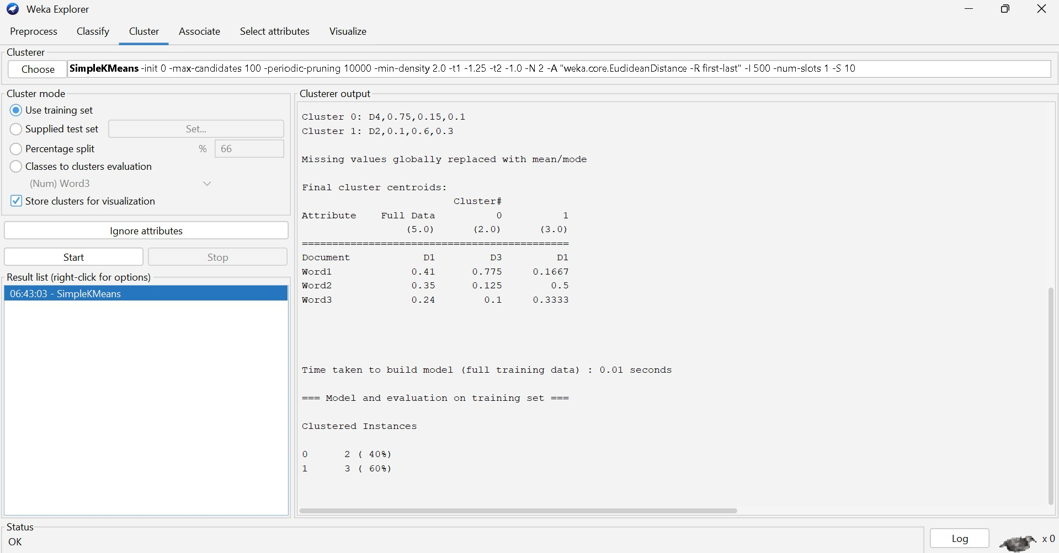

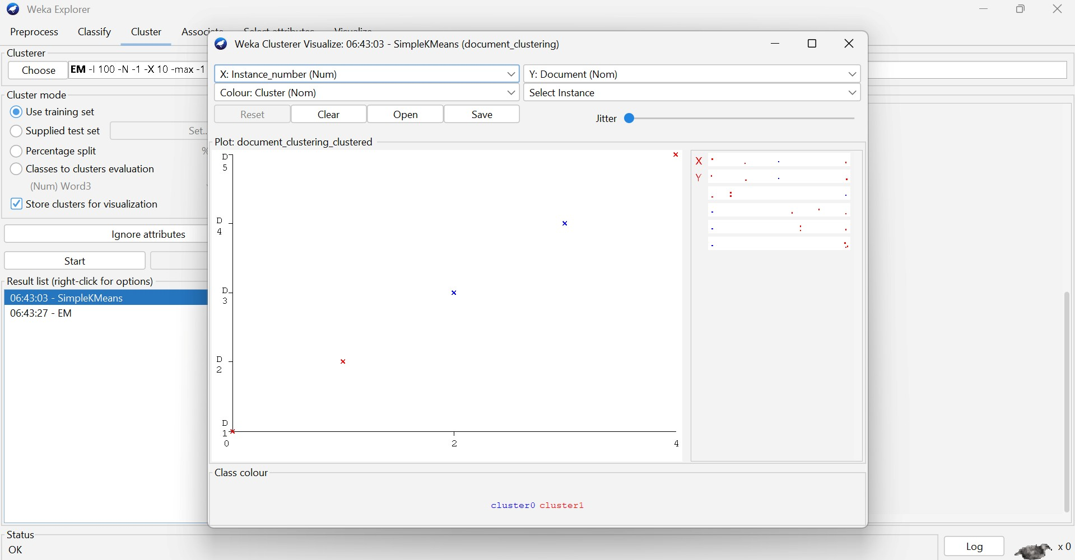

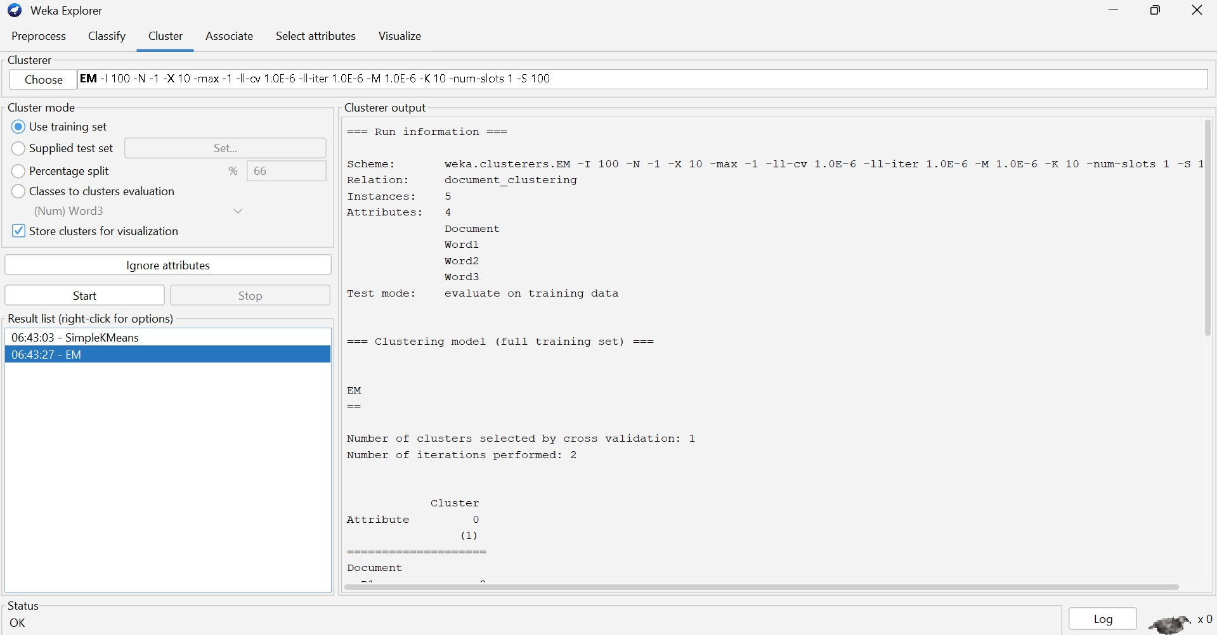

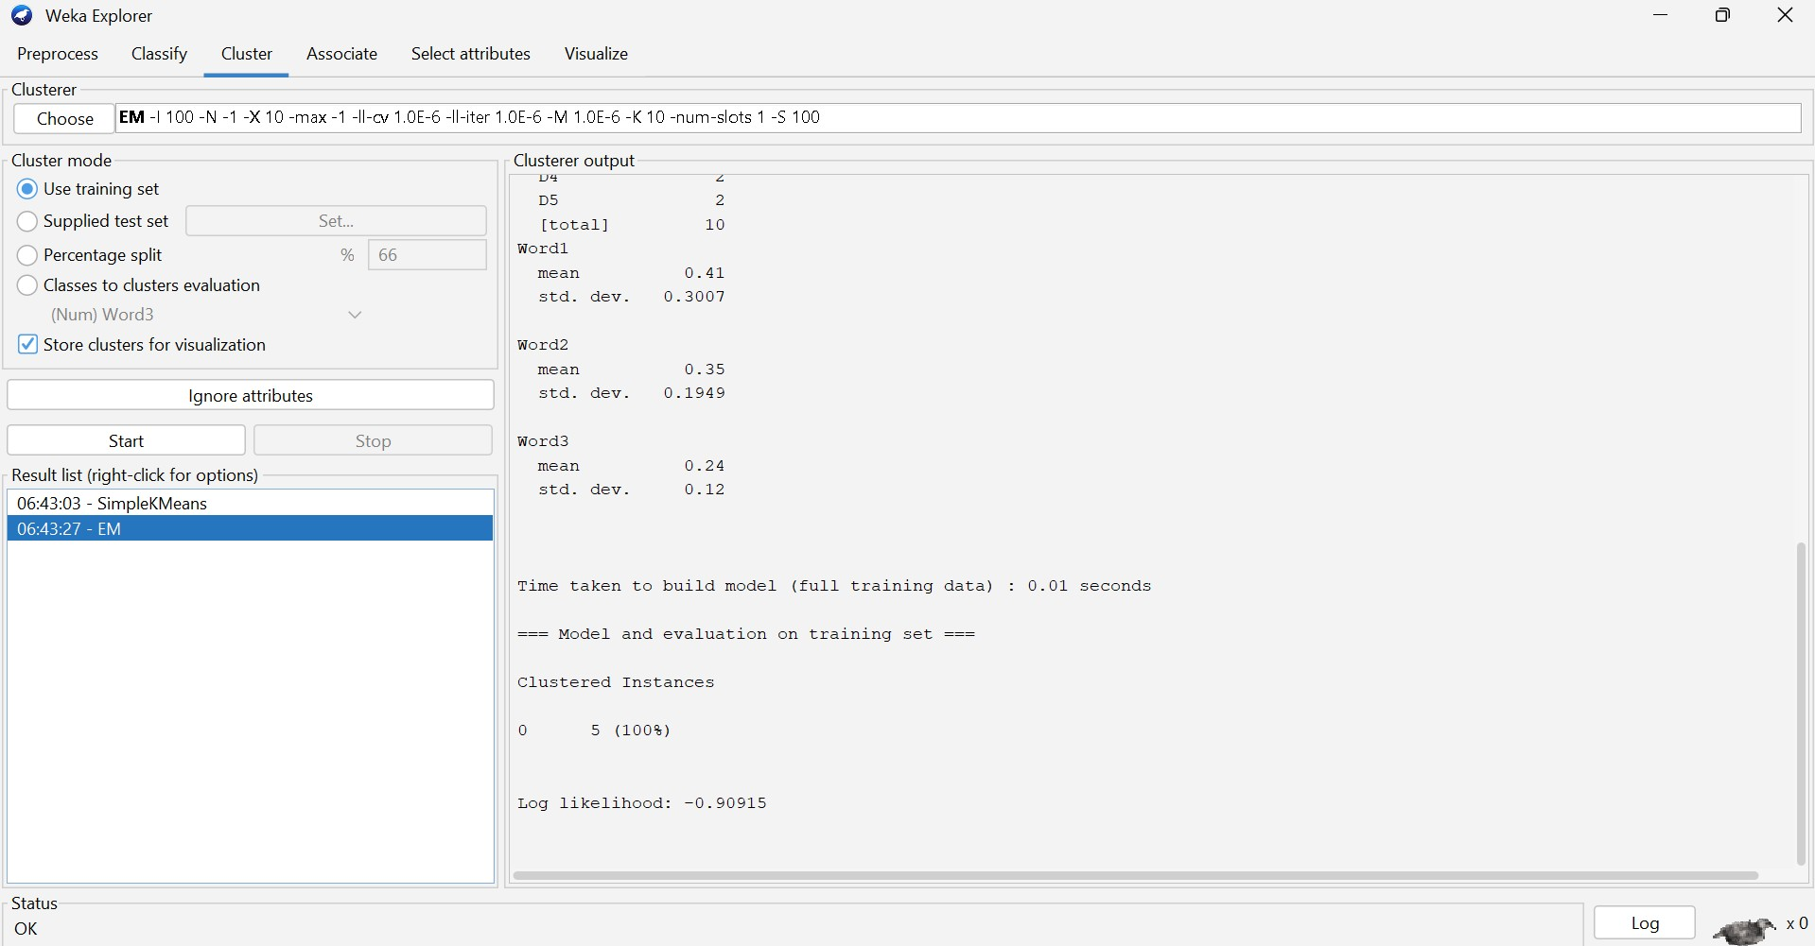

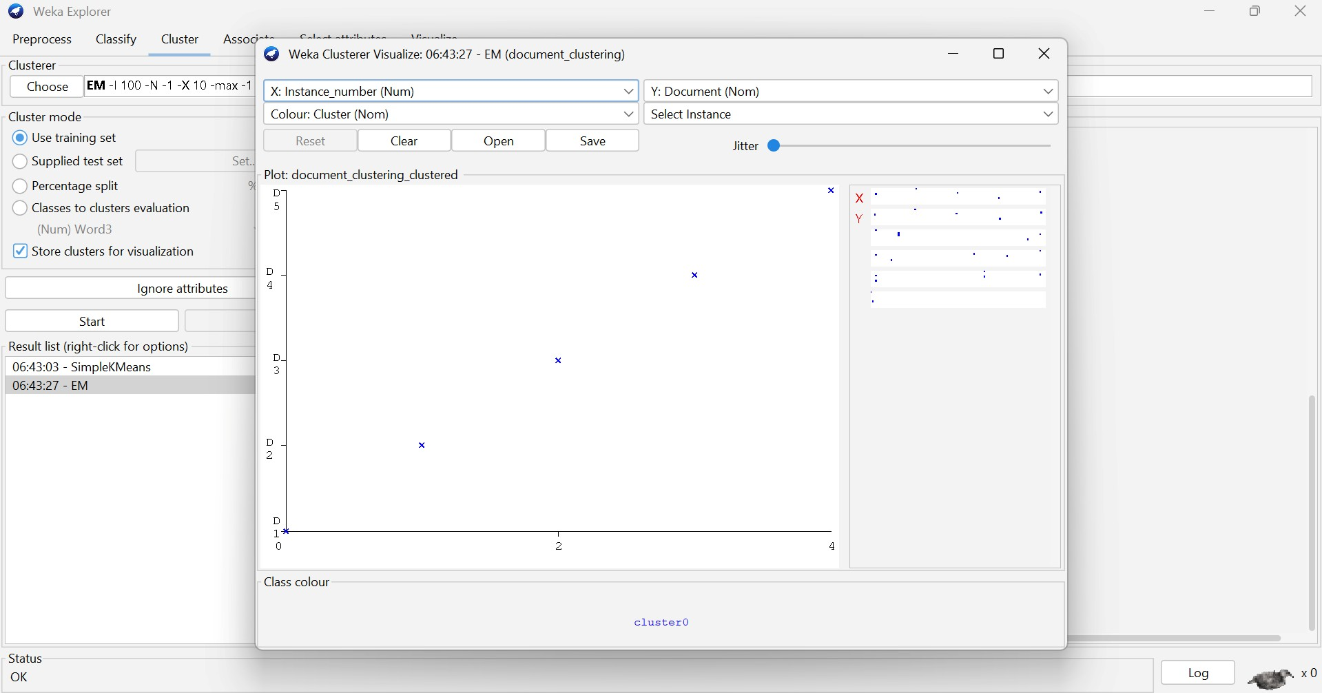
Q3. Dataset: Geographic Data Point Latitude Longitude
P1 | 13.08 | 80.27
P2 | 13.10 | 80.25
P3 | 12.97 | 80.22
P4 | 13.05 | 80.30
P5 | 13.00 | 80.20
Question:
Compare Euclidean and Manhattan distance metrics and analyze their impact on clustering results. (BL4 – 1 Mark)
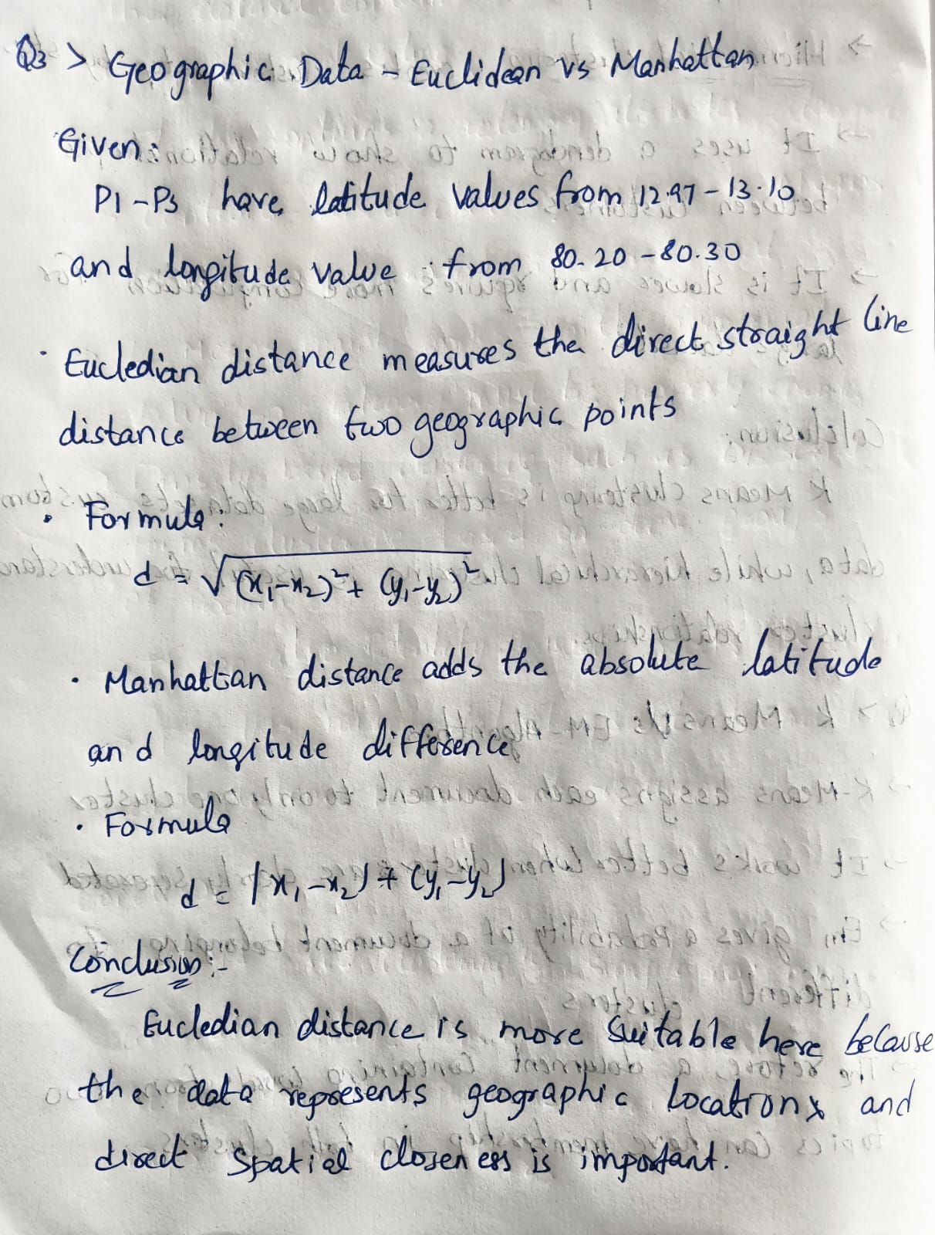

OUTPUT:
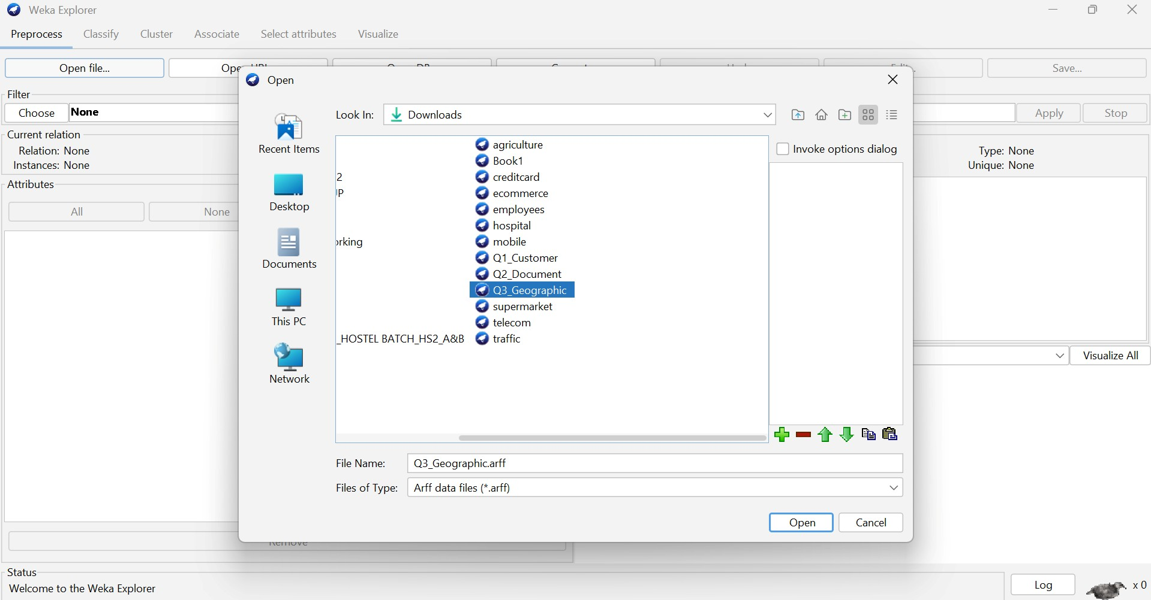

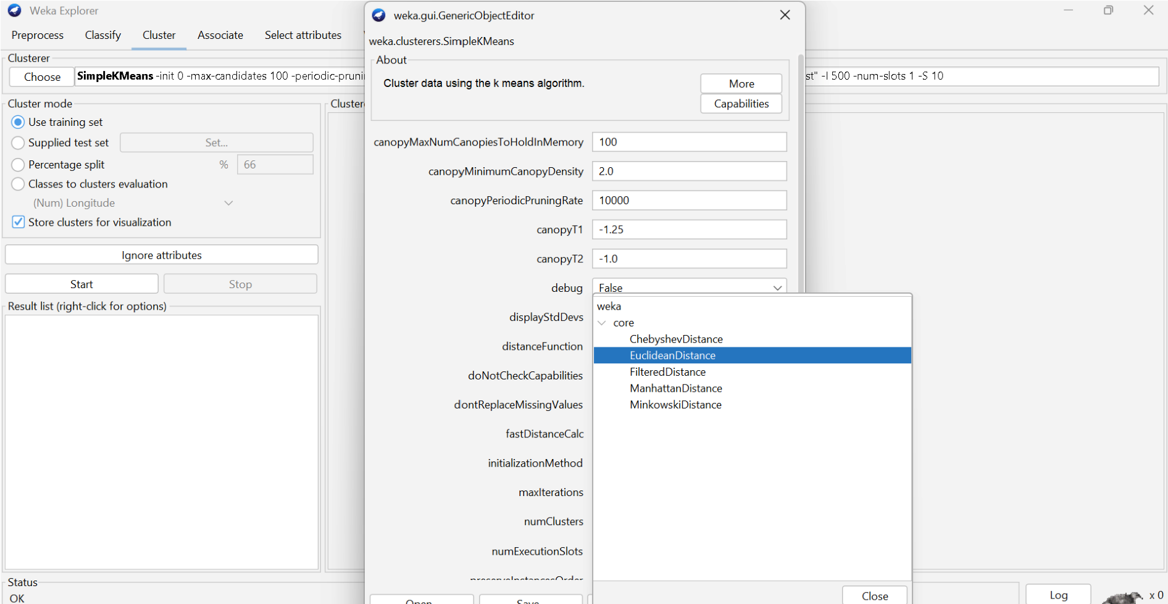

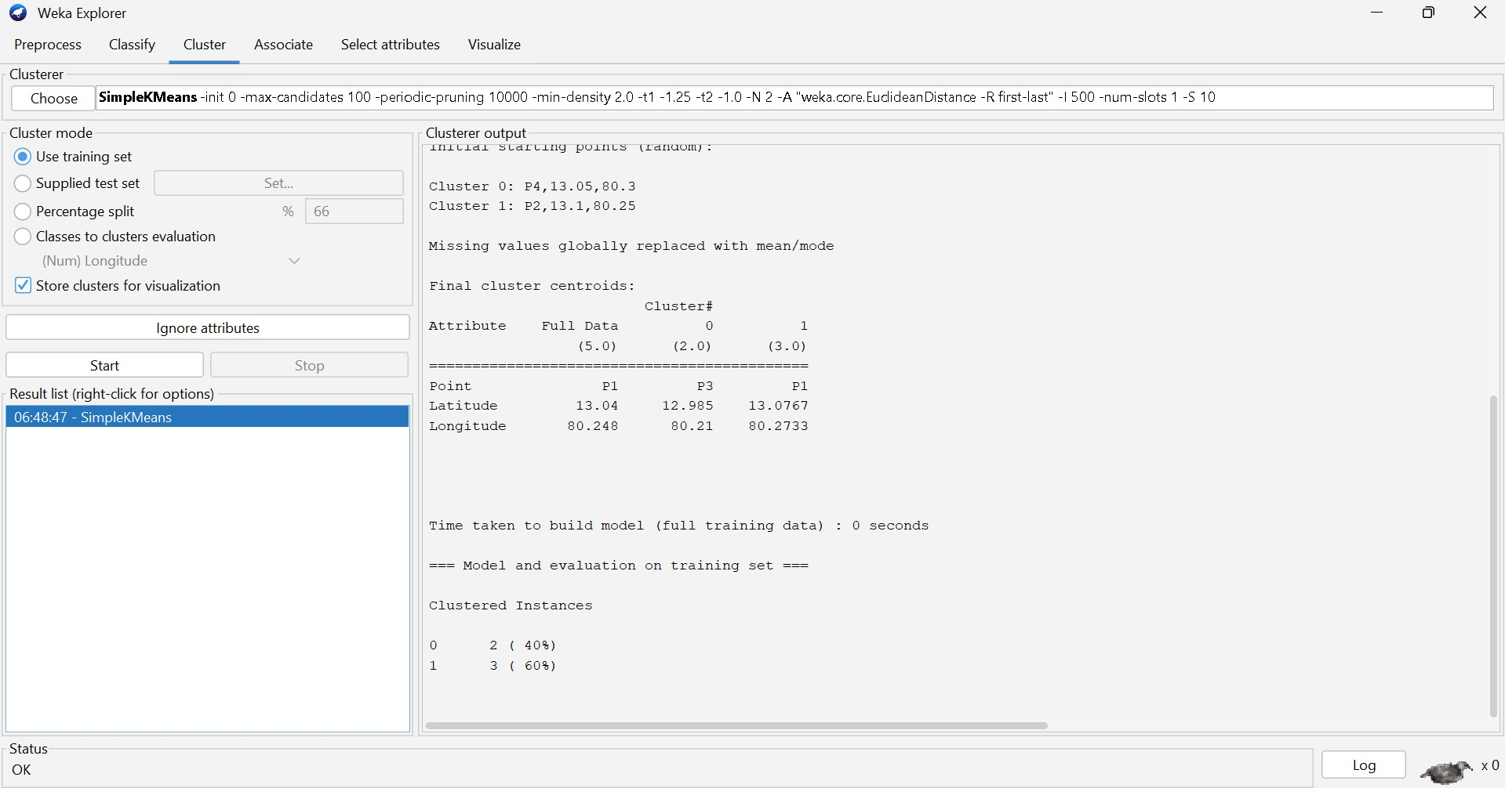

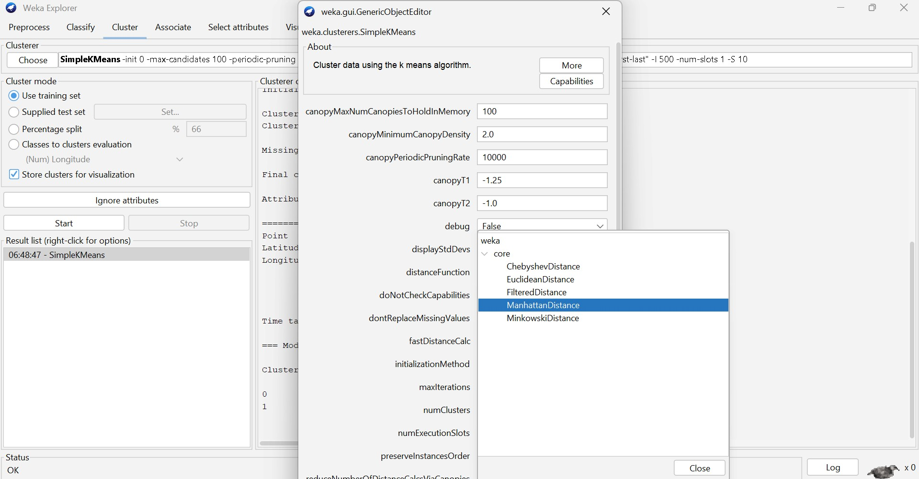

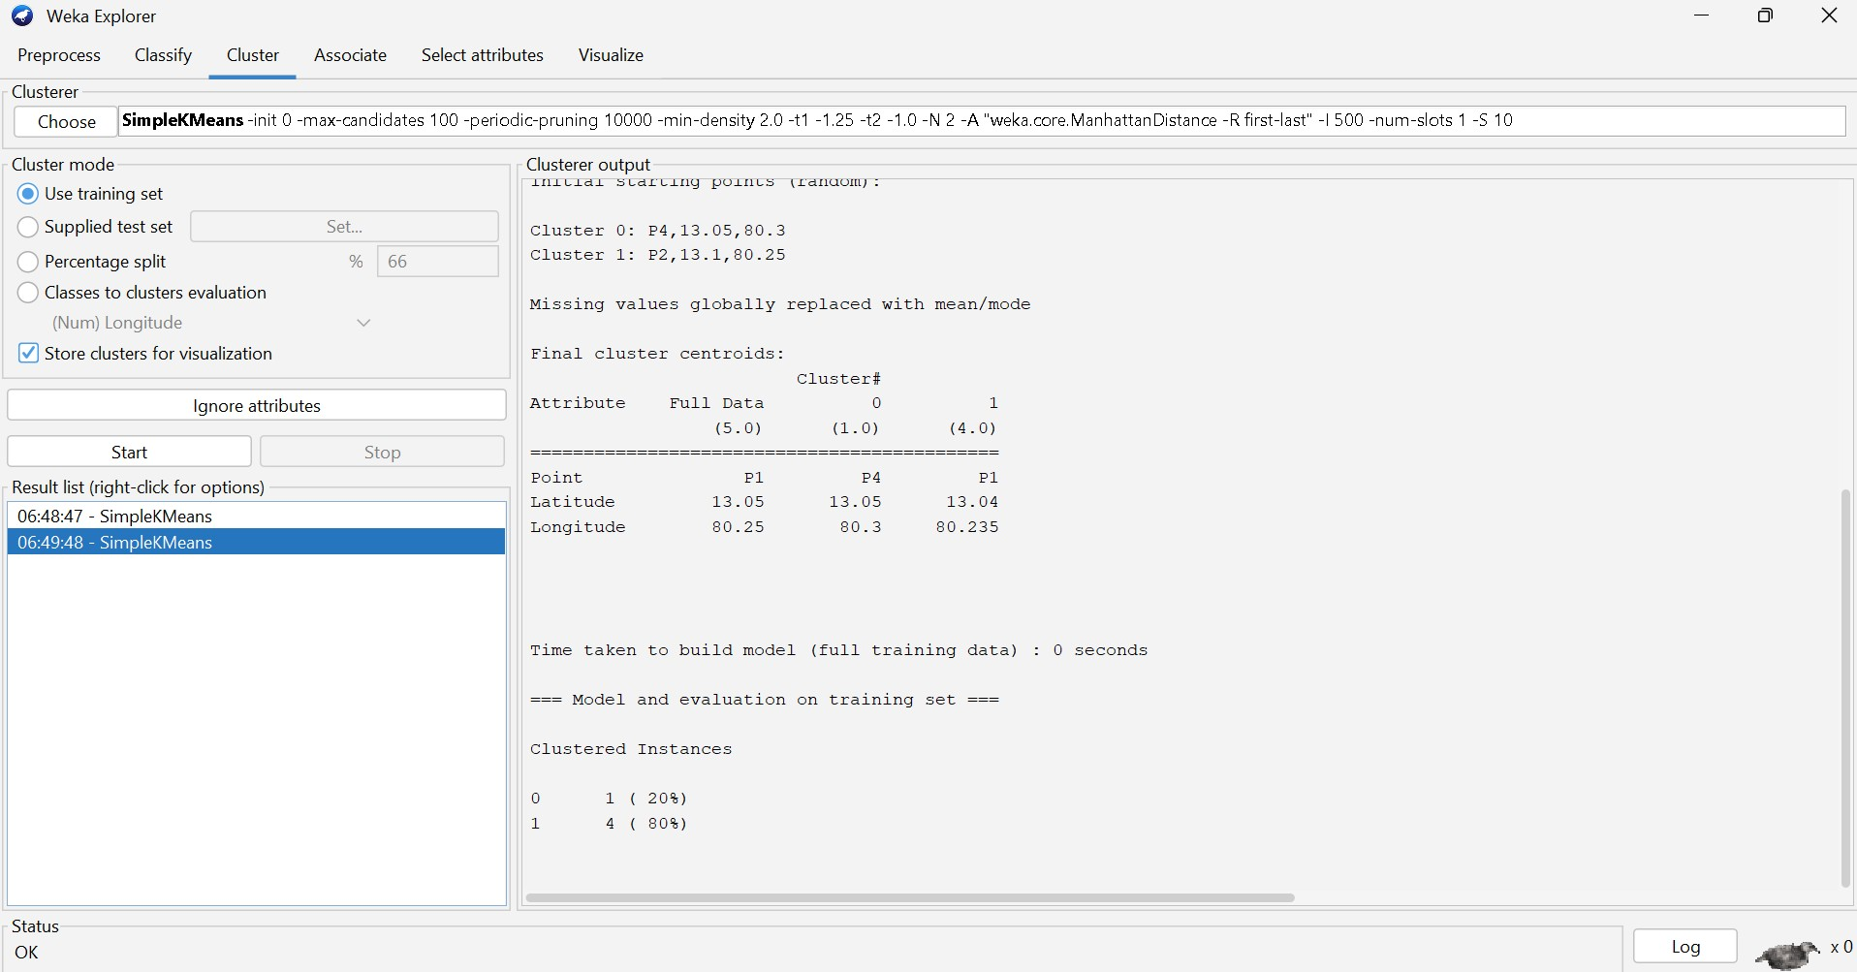

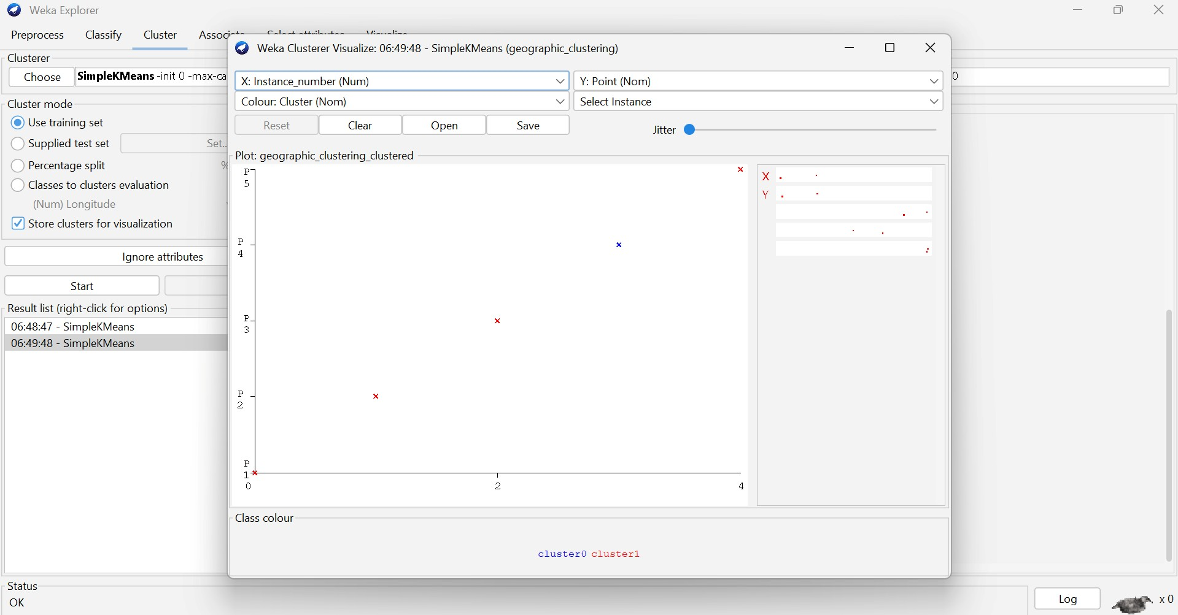

Q4. Dataset: Retail Products Product Sales (₹) Frequency
P1 | 50000 | 20
P2 | 30000 | 10
P3 | 52000 | 22
P4 | 25000 | 8
P5 | 32000 | 12
Question:
Compare agglomerative and divisive clustering approaches and explain their suitability for this dataset. (BL3 – 1 Mark)
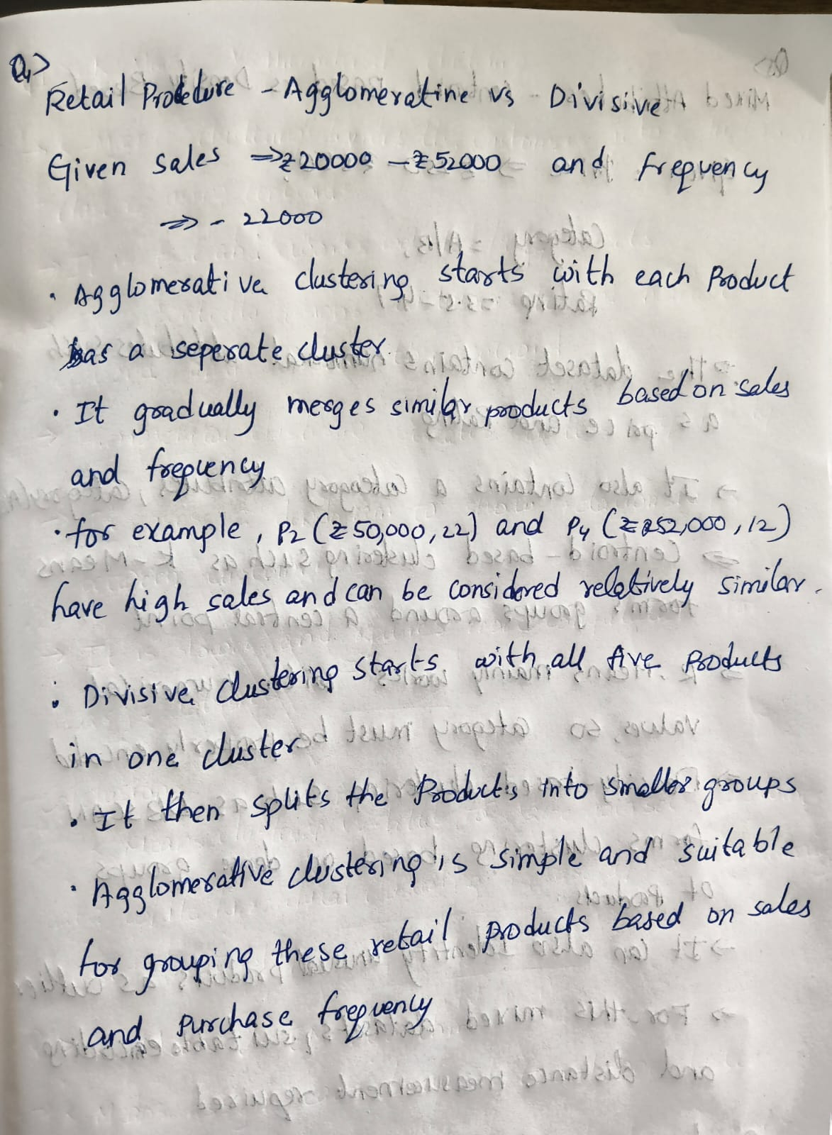
OUTPUT:
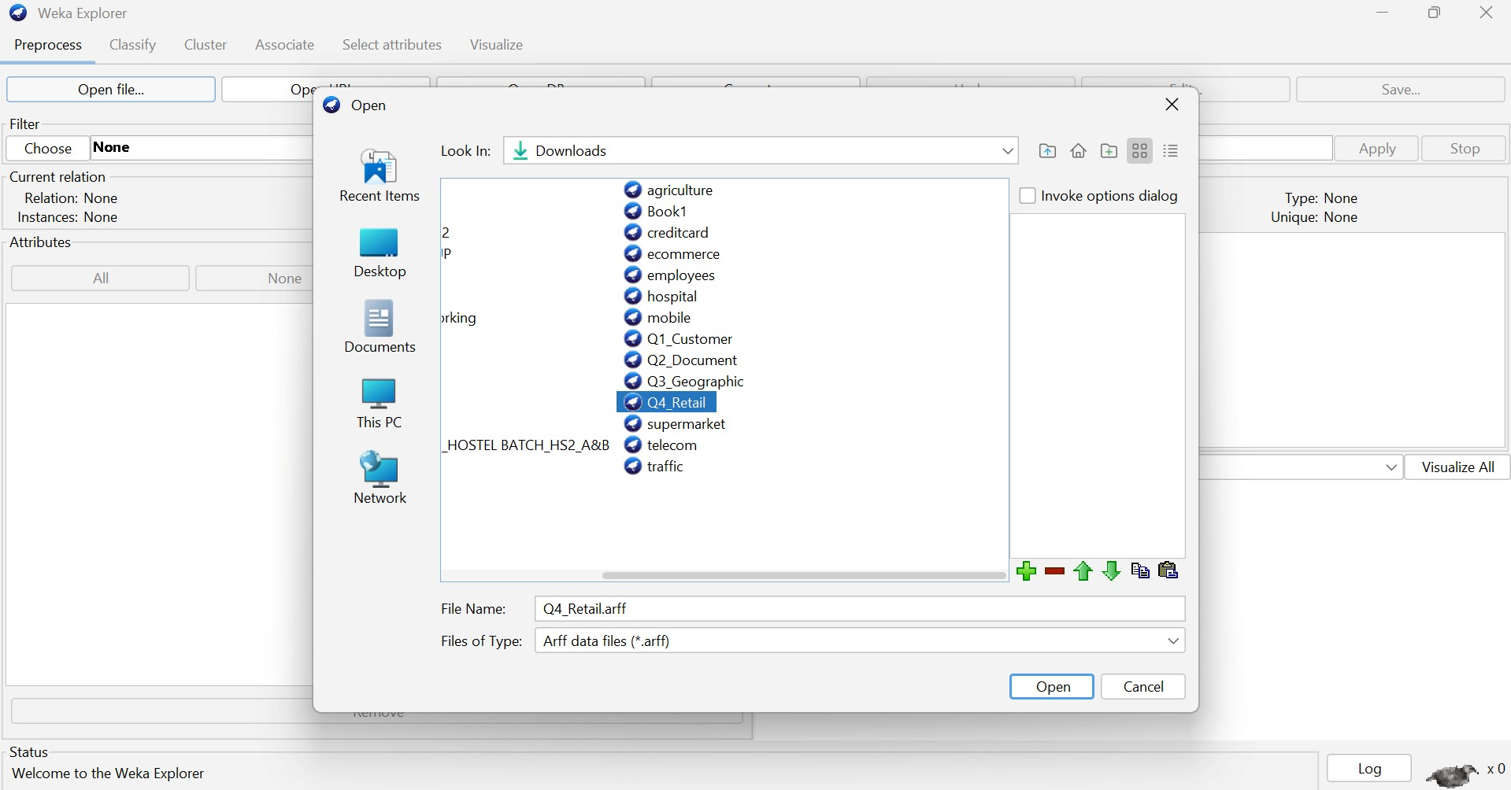

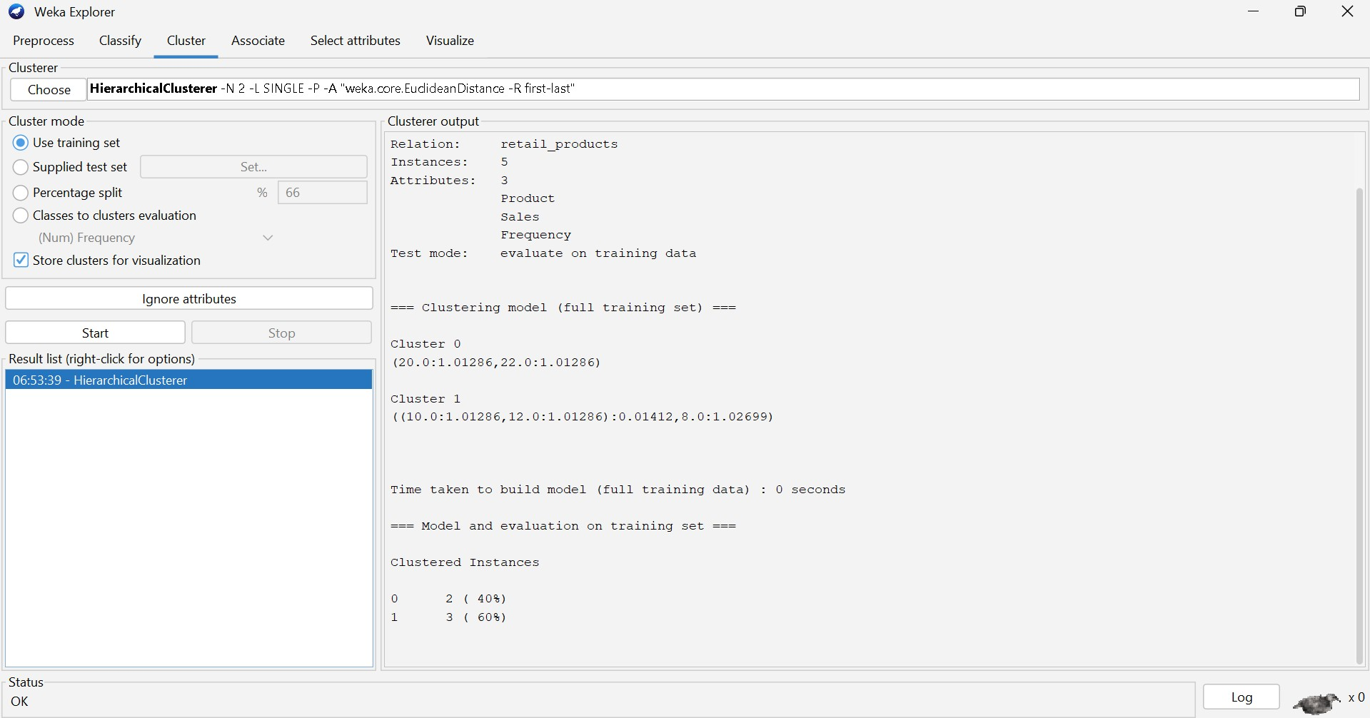

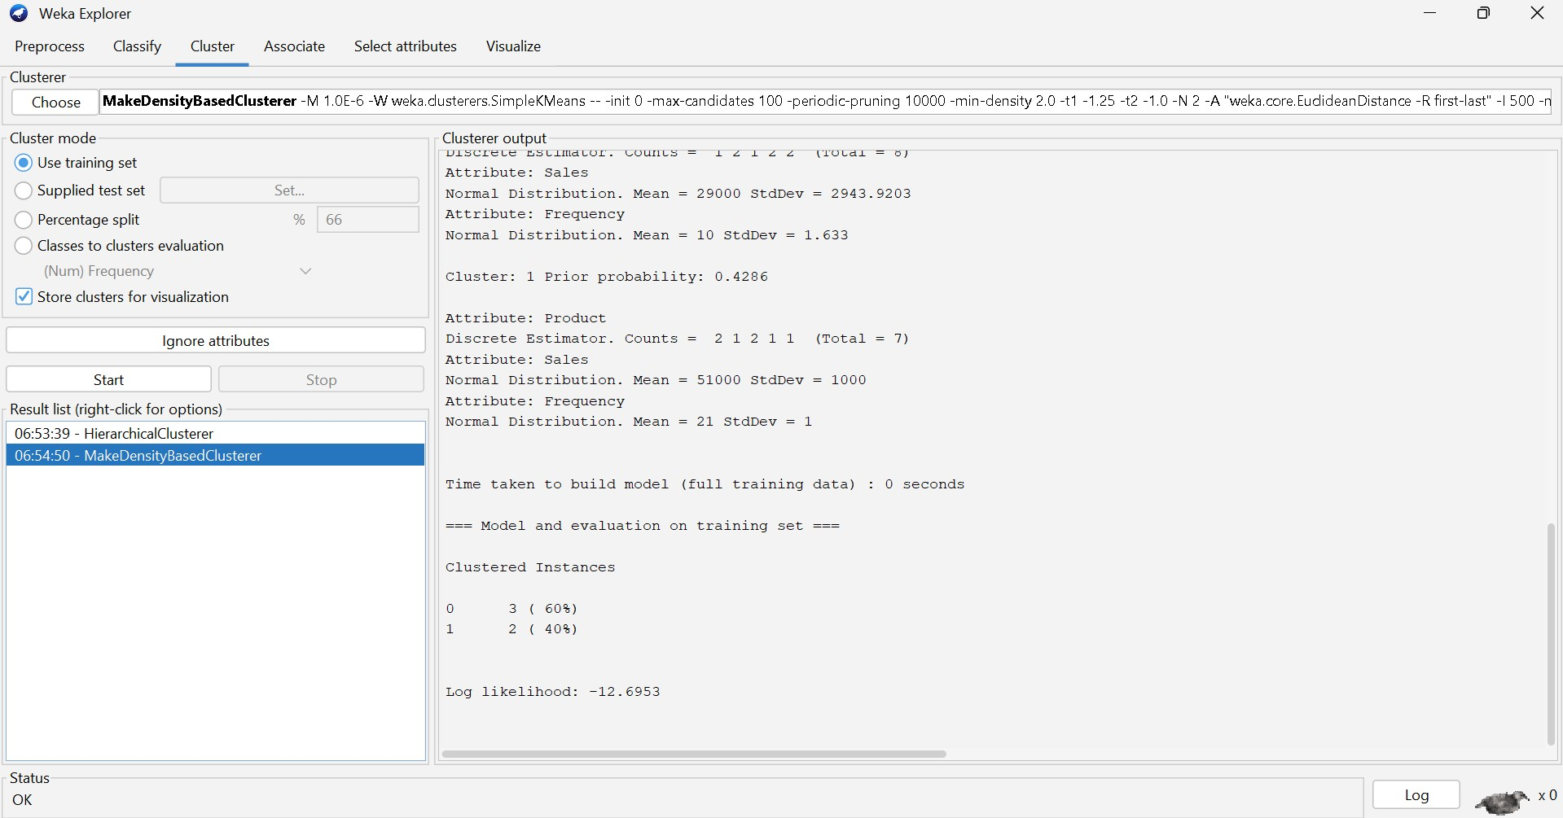

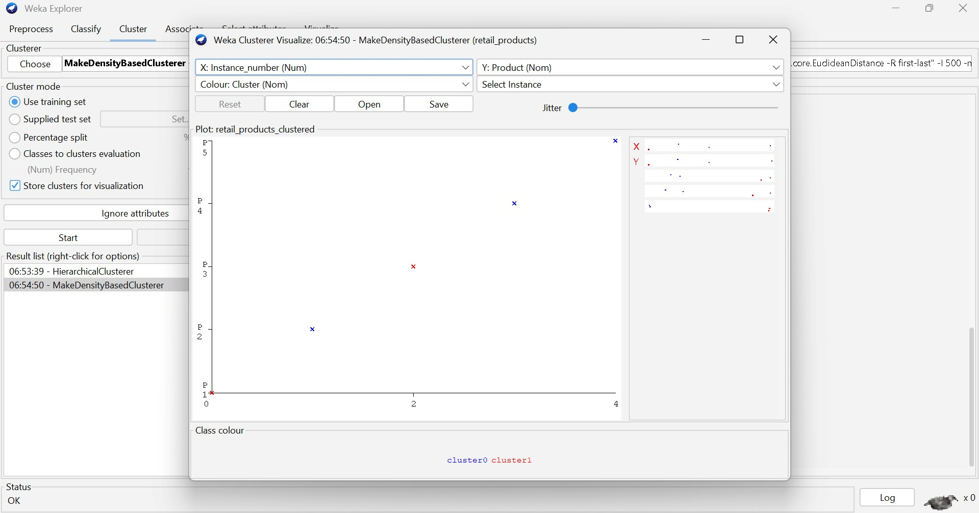
Q5 . Dataset: Mixed Attributes Item Price (₹) Category Rating
I1 | 500 | A | 4.5
I2 | 300 | B | 3.8
I3 | 550 | A | 4.7
I4 | 250 | B | 3.5
I5 | 520 | A | 4.6
Question:
Compare centroid-based and density-based clustering techniques and analyze their effectiveness on mixed data types. (BL4 – 1 Mark)
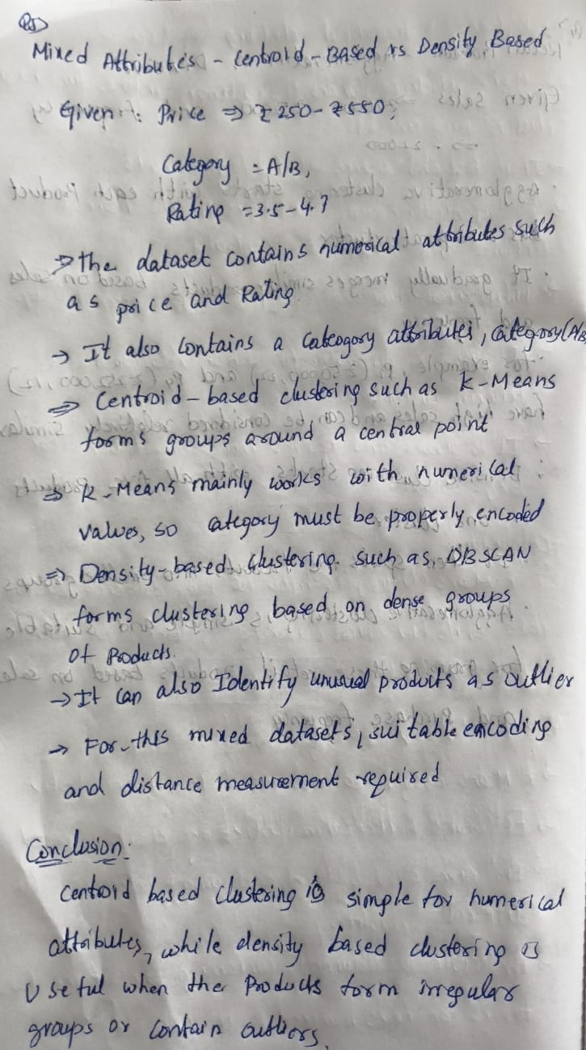
OUTPUT:
